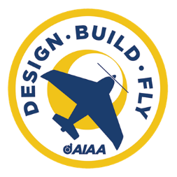

University of Houston – Space City Aeronautics
2025 – 2026 AIAA Design, Build, Fly Proposal
- Executive Summary
This proposal is the best proposal American Institute of Aeronautics and Astronautics has ever seen. I am writing these words to check formatting. Do NOT freak.
- Management Summary
The UH 2025-2026 DBF team consists of [insert number of members here]. The team manages managers to manage Minecraft things because we are farmers
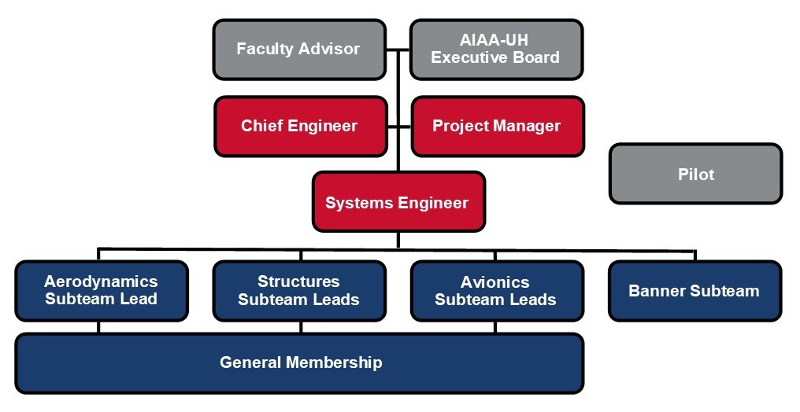
- Conceptual Design
  - Analysis of Mission Requirements
We have analyzed the mission requirements. Here is what we found:
  - Sensitivity Analysis
The big beautiful sensitivity analysis plot goes here.
  - Preliminary Design
    - Landing Gear Configuration
In our testing process, there was a natural inclination towards a taildragger configuration, one that our team has prior experience with. However, after referring back to the rules, and as our trade study progressed, a simpler solution presented itself.The trade study evaluated a tail dragger, tricycle, and quadricycle based on their respective qualities in the following, going from most to least important: landing characteristics, banner interference, structural integrity, and ground stability.
  - Empennage Configuration
For this design decision, all subteams were stakeholders, due to needing to utilize space in the rear of the aircraft. The trade study for the tail configuration of the aircraft consisted of a variety of configurations such as a T-tail, V-tail, H-tail, and conventional tail. The selected options were evaluated based on controllability, drag, high wing compatibility, aerodynamic stability, banner integration, and weight. Ultimately, the biggest factor in the decision to use a conventional tail stemmed from the possible interference that an H-tail could have on the towed banner.
    - Wing Configuration
The wing placement decision was solidified by the decision matrix, which indicated that the high wing placement was the best option out of three choices: high, low, and mid height positions. The criteria were based on the following, in order from most to least important to the decision, aerodynamic stability, manufacturability, ease of integration, and payload space.
    - Fuselage Configuration
The team chose an integrated fuselage to allow for more passengers and cargo

    - Airfoil Selection
When looking at the wigh

    - Propulsion System – I know this not a section, but I need to put this somewhere
For the Avionics/Propulsion system of the aircraft, the team has selected these components based on price, weight, functionality, and maximizing flight time. The Spektrum NX8 DSMX transmitter connects to the Spektrum AR8360T 8 channel receiver through the 2.4GHz radio band. This receiver was chosen due to its compatibility with our current transmitter and the number of control channels. The receiver controls the ESC and the 7 Daryl servos. These servos control the 5 control surfaces on the wings and empennage, as well as the banner release system. The aircraft’s propulsion system will utilize the maximum allowed battery capacity of 100Wh. This will be done with a Liperior 4500mAh 22.2V 6s battery rate at 99.9Wh. This battery will powers the 370kv SunnySky X5320 Motor with a 20*8 propeller. This motor and propeller was chosen due to its high thrust of 6650gf, reasonable current draw of 61.2 Amps, and the overall efficiency of this motor and propeller combination. The Spektrum Avian 100A electronic speed controller was chosen to control the motor due to the current requirement, price, weight, and its programmable capability.
    - Banner Release Mechanism

Overview of preliminary design

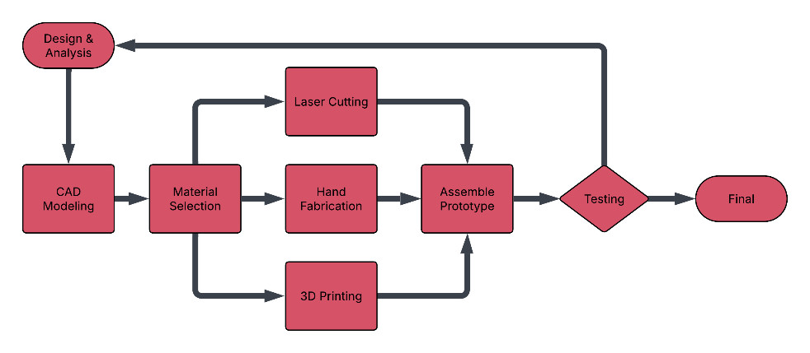
- Manufacturing Plan
  - Manufacturing Overview
This year, the team aims to develop a high quality prototype and conduct rigorous testing to gather performance data and validate design decisions. The goal is to use the insights gained from testing to optimize the final competition aircraft. The overall manufacturing process is outlined in Figure X.
  - Critical Processes
The primary structure of the fuselage, wings, and empennage will be fabricated using laser-cut ribs made from a combination of basswood and balsa, providing an optimal balance between structural strength and weight efficiency. Once assembled, the airframe will be covered with Monokote to improve aerodynamic smoothness and reduce drag. Components with complex geometries, including the nose cone and landing gear fairings, will be additively manufactured using PETG-CF filament to achieve high strength, dimensional accuracy, and reduced mass. Control surfaces will be constructed from foam, shaped precisely using a hot wire foam cutter to ensure lightweight design and aerodynamic consistency. The passenger mounting mechanism will be fabricated from flexible TPU filament to accommodate variations in passenger (duck) size while maintaining secure attachment. Finally, the banner deployment and release mechanisms will be 3D printed to ensure precision, repeatability, and seamless integration into the overall aircraft design.
- Test Planning

